ExNo:5 //OPERATOR

PROGRAM:

<html>

<body>

<p>x value=9<br>y value=2<br> multipication operator z = x\*y<br> </p>

<p id="3"></p>

<script>

var x=9;

var y=2;

var z=x\*y;

document.getElementById("3").innerHTML =z;

</script>

</body>

</html>

OUTPUT:

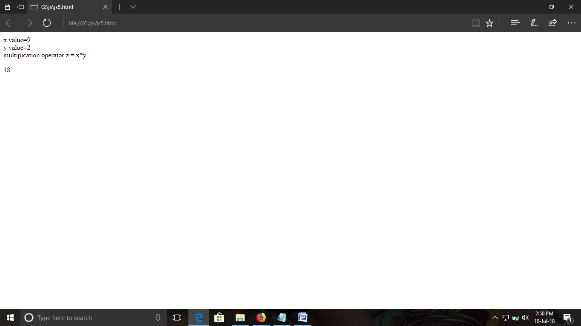

ExNo:6 //ONCLICK ACTION

PROGRAM:

<html>

<body>

<center>

<p><b>IF THE BUTTON CLICK IT WILL SO THE TIME AND DATE</b></p>

<button onclick="this.innerHTML=Date()">click here </button>

</center>

</body>

</html>

OUTPUT:

